* **Activity 11:**

Retrieving Data Using FULL OUTER JOIN

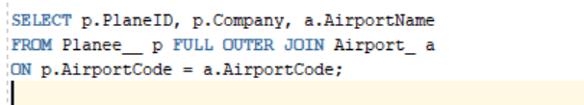

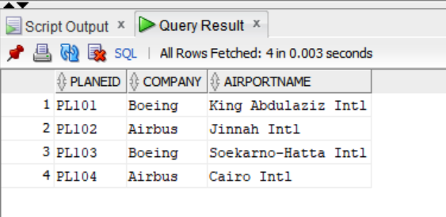OUTPUT: